Spotlight on Moulin-à-Vent 2018: 72 wines tasted and rated

Considered the ‘king’ of the ten Beaujolais crus for the power, concentration, structure and ageability of its wines, Georgina Hindle tastes over 70 from the 2018 vintage…

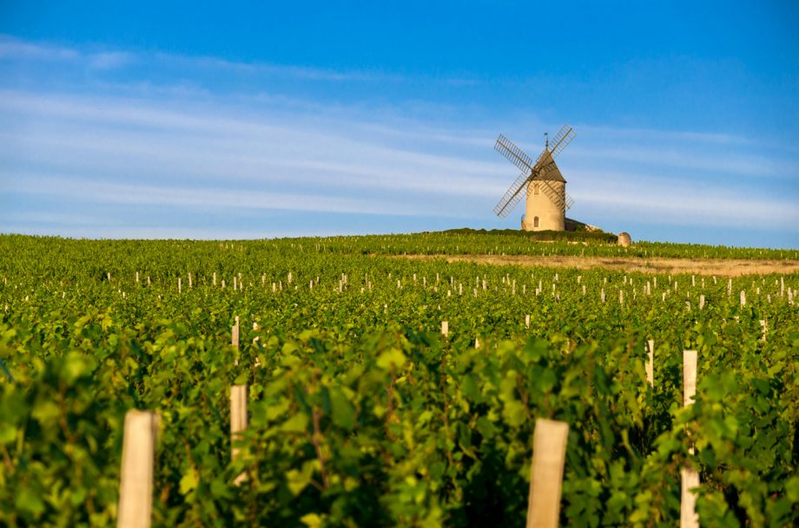Mill of Moulin a Vent village in Beaujolais land Credit: Gaelfphoto / Alamy Stock Photo

Situated in the north of the [Beaujolais](https://www.decanter.com/wine/wine-regions/burgundy-wine/beaujolais/) region, Moulin-à-Vent is one of the most famous crus and named after the local windmill – the literal translation of the name.

It is a historic appellation with a vine-growing history dating back hundreds of years. It was officially granted appellation status in 1936 – one of the first in the country.

[Georgina Hindle](https://www.decanter.com/author/georgina_hindle/) August 20, 2020

**Pierre-Marie Chermette, Les Trois Roches, Moulin-à-Vent, Beaujolais, France, 2018**

This is bright with crisp cherry fruit, freshly picked strawberries and blackcurrant juice. Really succulent and inviting with distinctly perfumed elements - peonies and violets and some chalky minerality. A complete wine that's full of character and can be drunk now or left to age.

**Points 91**

